Premier Publishing s.r.o.
https://ppublishing.org
pub@ppublishing.org
II International Scientific and Practical Conference
«ECONOMIC SCIENCES AND MANAGEMENT
IN THE MODERN WORLD»
The conference will be held on February 10, 2023 and will be held as a teleconference, followed by the publication of the conference proceedings.
The conference proceedings will have an international ISBN number
Location: Prague, Czech Republic
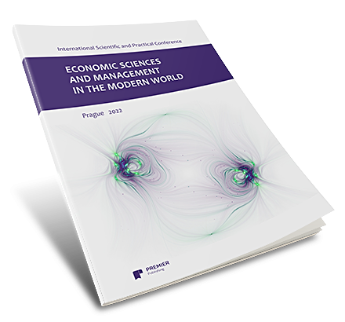
Conference sections:
- Accounting
- Logistics
- Marketing
- Mathematical and instrumental methods of economics
- Management
- World economy
- Regional economy
- Standardization and product quality management
- Statistics
- Innovation management
- Finance, money circulation and credit
- Pricing
- Economic theory
- Economics, organization and management of enterprises, industries, complexes
- labor economics
- Population economics and demography
- Environmental economics
- Business Economics
- Economics of recreation and tourism
economic security

AT THE END OF THE CONFERENCE
Each participant receives FREE OF CHARGE

 | ARTICLE PREPRINT  Immediately after payment, with all metadata, citation and online link |  |  | PUBLICATION CERTIFICATE  Available for download immediately after payment in your personal account
 | CONFERENCE PROCEEDINGS, Certificate and Programme of the Conference  Available for download 14 days after the conference date |  |  | PERSONAL ACCOUNT  The certificate of participation is available for download in the account
The collection will be available article by article in the publisher's archive, as well as in
HOW TO ATTEND THE CONFERENCE
1. Fill in the application form on the website or send the article and the author's details to pub@ppublishing.org
2. After passing the review process, you will receive a message by mail within 3-5 days with a full calculation of the cost and all possible payment methods.
3. Pay for the processing of your article and its publication to the details given. Important! The cost of publication and payment will be calculated only after the Organising Committee has received the article.
CONFERENCE TARGET DATES
Informing the author of the acceptance of an article for publication | Within 3 days of receipt of articles
Acceptance of payment | Within 3 days of receipt of payment
Preprint of the article on the website | Immediately after payment
Receipt of publication certificate | Immediately after payment
Receipt of the Certificate and the Conference Proceedings in electronic form | 14 days from the date of the conference
Placement on Elibrary | 14 days from the date of the conference
RATES FOR ARTICLE PUBLICATION AND DELIVERY SERVICES
Service | Price
Fee, publication of 2 to 7 pages | 20 €
Publication of 1 page of text if space is exceeded | 4 €
Figures (photos, diagrams), formulas or tables in the text | + 20% of the final cost of the publication
DOI | 5 €
Contribution for co-author (if any) | None
Obtaining an electronic copy of the conference proceedings | Free of charge
Certificate of electronic publication | Free of charge
Certificate of participation in electronic form | Free of charge
PAYMENT METHODS:
More than 10 payment options are available to authors for publishing by online wallets, payment aggregators or online bank cards.

APPLICATION FORM (Copy to separate file and fill in)
Full name of the author
Name of the conference | International Scientific and Practical Conference  «ECONOMIC SCIENCES AND MANAGEMENT  IN THE MODERN WORLD»
Name of article
Section
Place of work or study, position
Academic degree, academic status
Contact phone number and e-mail address
I confirm that I have read and understood the principle for calculating the number of pages to be published and accept it when calculating the cost:
1 standard page = 1800 characters without spaces. | YES
GENERAL REQUIREMENTS FOR ARTICLES AND APPLICATIONS
Name of the file with the author's details (application for publication) | A separate file titled “Application - Author's name” (e.g. Application - Petrov)
Name of the file with the article | A separate file titled “Article Categoty Number - Author's Last Name” (e.g., “2 – Petrov”)
File type | Microsoft Word 97-2010 (doc, rtf)
Page size | А4
Margin | top and bottom 2 cm, left 3 cm, right 1.5 cm
Font | Times New Roman
Text alignment | justified
Indentation | 1.25 cm.
Page numbering | No
Page reference formatting | СFootnotes are placed in square brackets in the body of the article
Organization of the reference list | If desired, references should be placed at the end of the article, arranged alphabetically and numbered.  See Appendix 2 for an example.
Figures / charts | Black and white, embedded in the text
Formulas | Created in Word's built-in formula editor
Word count | 5 pages and more (1 page = 1800 characters without spaces, number of pages rounded up to whole numbers)
DOCUMENT SET INCLUDES
- Orignial article of the author
- Apllication form for each author
- Review by the supervisor (external review)

Organising committee’s contacts:
Premier Publishing s.r.o.
https://ppublishing.org
pub@ppublishing.org
If you have any questions about the terms of publication, we will be happy to answer them by e-mail: pub@ppublishing.org
Annex 1. Design of the title page of the article and references to the literature
Ivanov Ivan Ivanovich,
South Federal University,
Postgraduate Student, Department of Political Institutions and Processes
invan.ivanov@mail.ru

State regulation of the security sector

The relevance of this problem is due to the complexity of ensuring the sustainable security of Russian society [1] and, at the same time, the urgent need to increase the organizing role of political power and state institutions in neutralizing the complex of modern dangers [2].

Table 1. - Table name

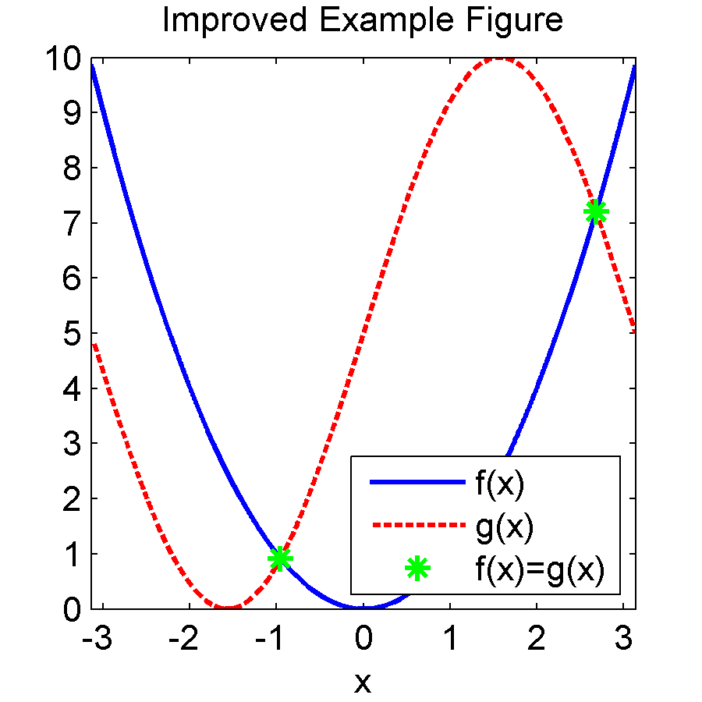
Figure 1. Figure title

Annex 2. Registration of the list of references

References

1. Ivashov L.G. Military reform in Russia: state and prospects. Materials of the "round table": "Public control of the national security policy." Ed. S.S. Sulakshina. - M. - "Scientific expert". – 2020.
2. Koshkin A.P. State regulation in post-Soviet Russia. - Smolensk. – 2018.

