EXAMPLE OF ARTICLES' COMPOSITION

1) The publishing house switches to the APA style of formatting articles and footnotes in them
2) Now we use Creative Commons License to cite publication
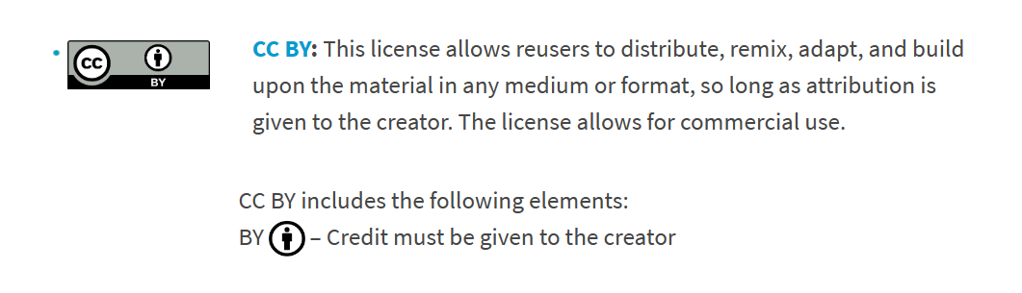
You will find an example of article formatting below.
1) The first page of each article in the magazine will now contain:
- name of the magazine
- publishing house
- DOI
- link to license
- article title
- data of authors, which now contains only the place of work.
- example of a citation link
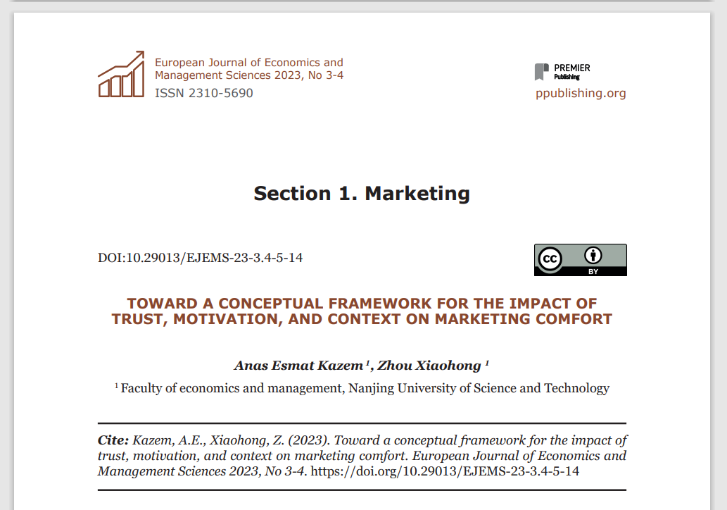
2) Drawings are now signed at the top.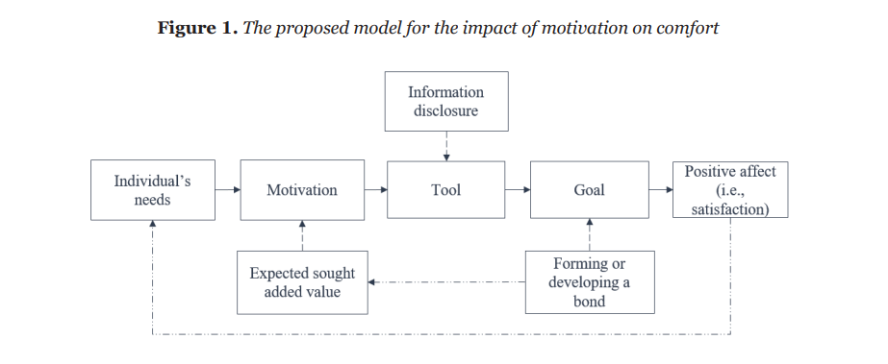
3) The title of the table is written at the top, the source is signed at the bottom. The table has no vertical divisions.

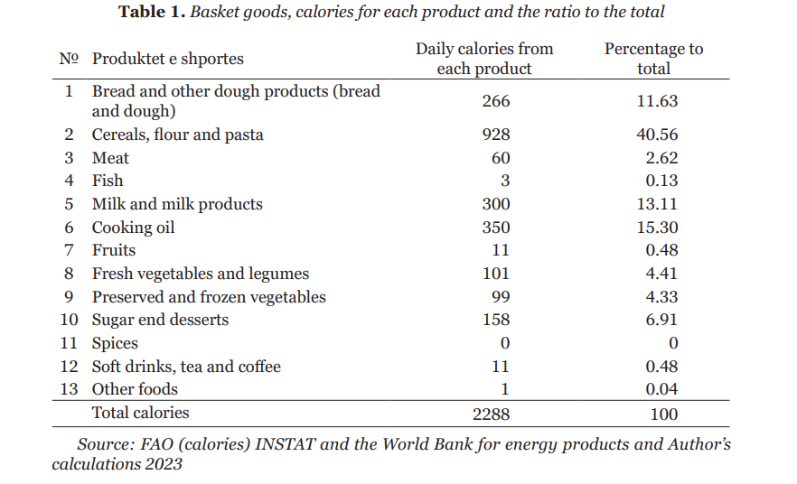
4) VERY IMPORTANT: it is now necessary to correctly format the links within the text and the list of references:
- the link within the text is in parentheses indicating the surname and year of publication
- the list of references is not numbered, it is arranged in alphabetical order, each new reference is separated from the other by a space
- the electronic resource must be indicated in the form
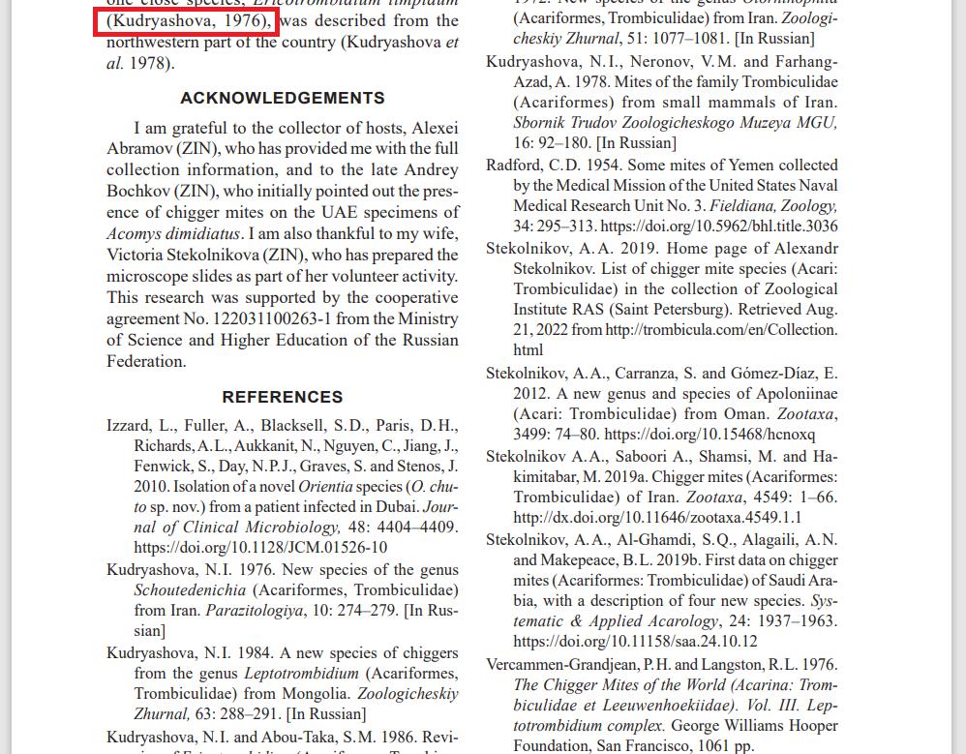
5) Dates of submission, acceptance and publication will now be posted at the end of each article

